**Reading Graphics** NAME: ____________________________

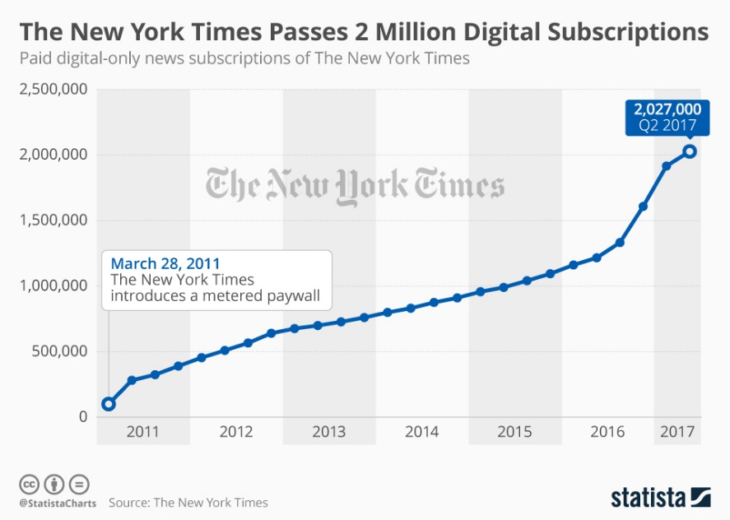

**TASK:**

Construct one question that asks a student to consider the claim/information in the graph as compared to the claim in President Trump’s tweet. Draft 4 answer choices.

Have one person from your group email me your question, answer choices, and answer key with an explanation of the right answer.

If you need to look at some sample questions, see below.

Email to: cremar@cbsd.org

In the subject line: #Block2

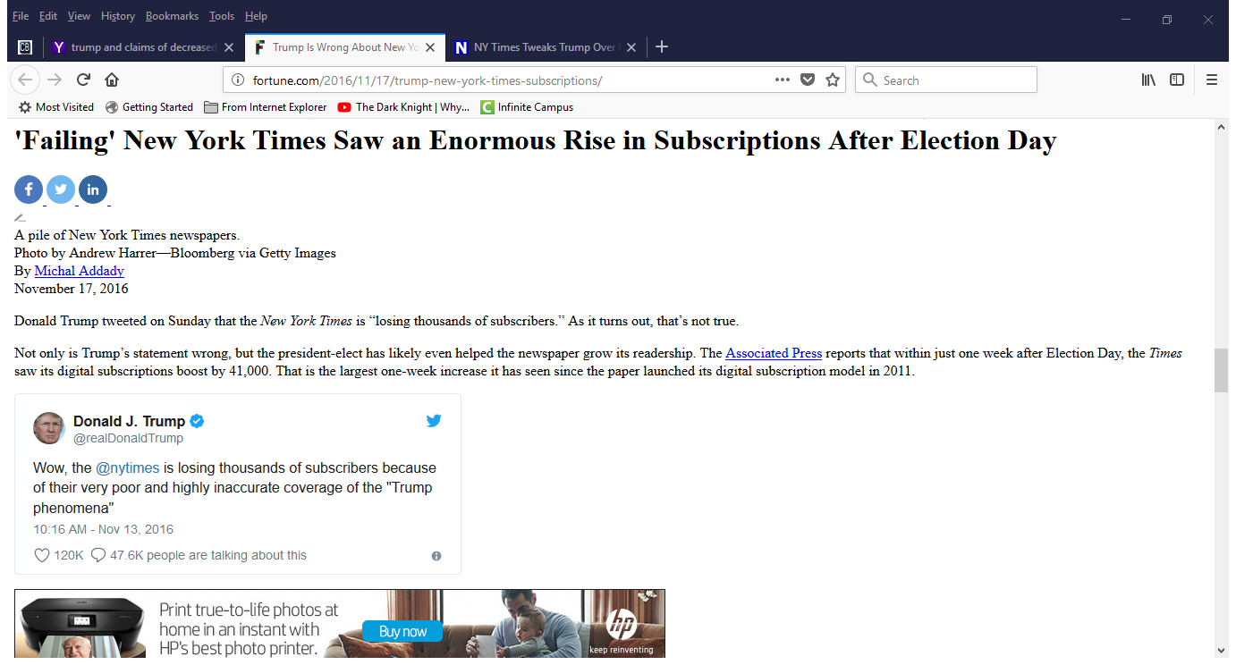

SAMPLE QUESTION STEMS:

* Which choice best describes the relationship between the passages?
* Which point about the resources that will be highly valued in space is implicit in Passage 1 and explicit in the graph?
* The author of the passage would most likely consider the information in chart 1 to be…
* The passage and the chart are in agreement that…